Miguel Fernandez Brazon
2/15/2026
Module 6.2 Assignment

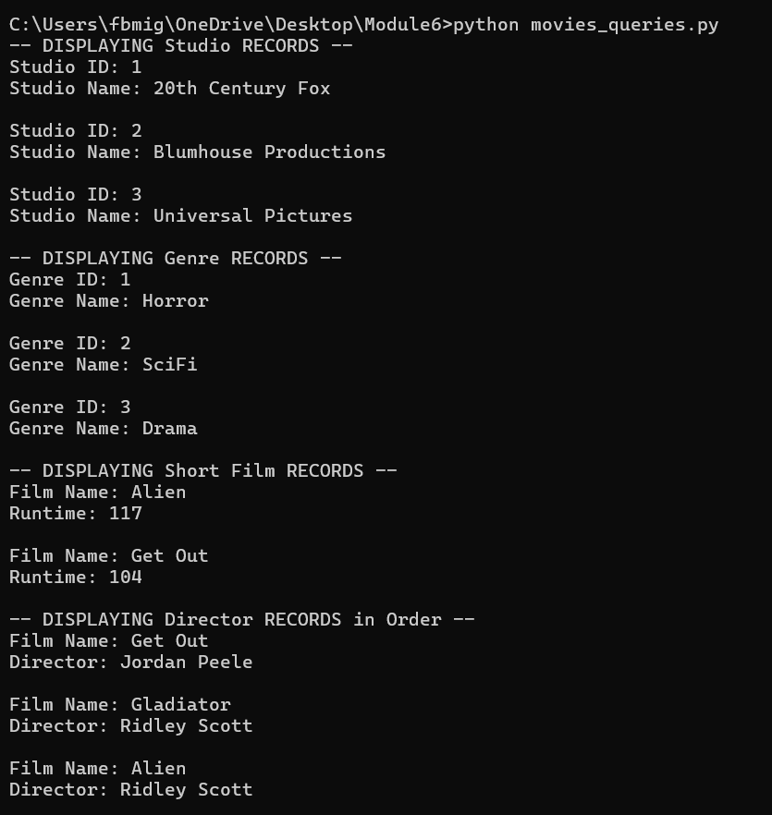
https://github.com/concord808030-tech/CSD310-300O-

